Shrinkage correlation: USDCHF and USDCAD
Method 08 / eight-major panel / delta = 0.2 and Ledoit-Wolf / Alpari D1 full available history

Study setup
Logical pair: USDCHF , USDCAD
Broker symbols: USDCHF_i , USDCAD_i
Snapshot: 2026-11-03_majors_alpari_D1
Timeframe: D1
Common eight-major panel window: 1999-01-06 to 2026-11-02 (UTC bar dates)
Panel matched return count n: 7127
Dropped unfinished last bar dated 2026-11-03 UTC after a tick-volume check against the prior complete day.
Fixed shrinkage: delta=0.2, mu=3.9170889e-05 (mean of diag(S))
Ledoit-Wolf estimated delta: 0.0042157642
Panel symbols: EURUSD, GBPUSD, AUDUSD, NZDUSD, USDJPY, USDCHF, USDCAD, EURGBP
Complete matched rows (Excel): USDCHF-USDCAD_Shrinkage_D1.xlsx
Complete matched rows (HTML table): USDCHF-USDCAD_Shrinkage_D1_data.html

Method carried forward
Shrinkage blends the sample covariance matrix S of matched daily log returns of close, ln(close_t / close_t-1), toward a simple target, then converts the shrunk covariance into correlations. Quotes are not inverted. This experiment builds one common calendar across all eight majors, forms S with the unbiased n-1 divisor, then reports two shrinkage specs: fixed delta = 0.2 with mu equal to the average sample variance (mu * I target), and sklearn Ledoit-Wolf with its estimated delta. Pair reports pull rho_ij from those panel matrices. Same-panel Pearson r is a side check only. Shrinkage improves conditioning; it is not a cause, not a lead, and not a trading signal.

Results
pearson_r | rho_02 | rho_LW | rho_02_minus_r | rho_LW_minus_r | delta_LW
0.304864 | 0.235326 | 0.303336 | -0.069538 | -0.001528 | 0.00421576

Conclusion
Over the common 7127-day eight-major panel for USDCHF and USDCAD (broker quote directions unchanged), fixed-delta shrinkage correlation at delta=0.2 is 0.2353 (positive, weak linear link in this sample). Ledoit-Wolf rho is 0.3033 with estimated delta=0.004216. Same-panel Pearson r is 0.3049 (rho_02 minus r = -0.0695; rho_LW minus r = -0.0015). This does not establish cause, lead-lag, or a lasting trading rule.

Charts
Daily closes
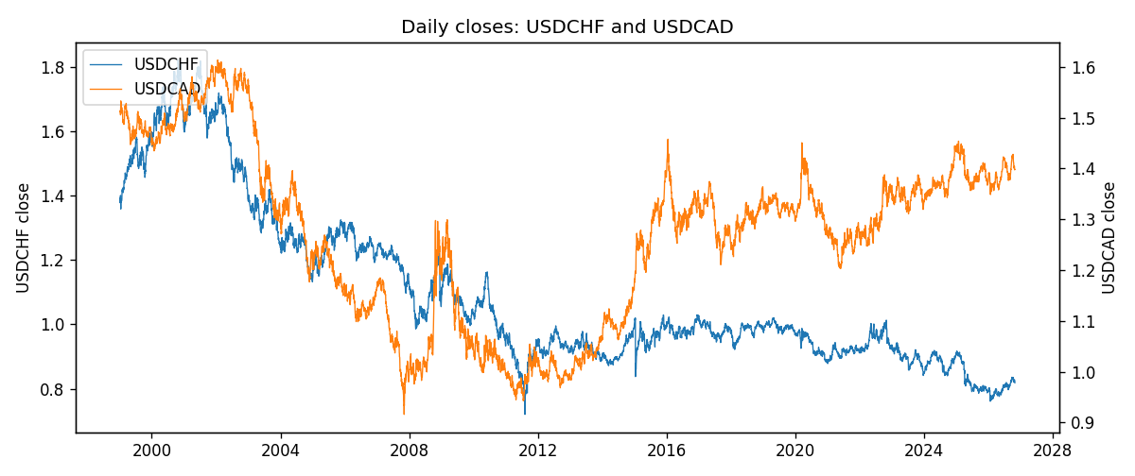
Daily log returns
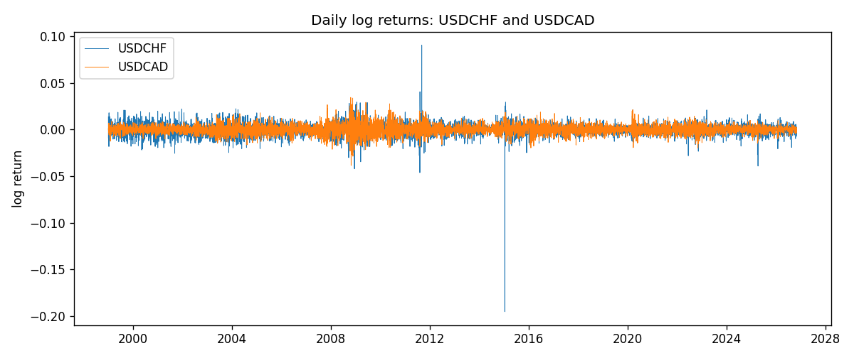
Log-return scatter
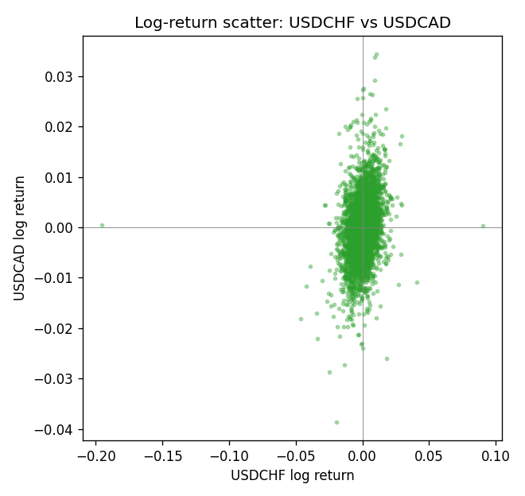

Data report
Every panel row for this pair slice is stored in the sibling Excel workbook named USDCHF-USDCAD_Shrinkage_D1.xlsx. Full-panel covariance and correlation matrices are saved once under outputs/ as CSV files. Embedding all rows as a Word table is impractical at this length; the Word file holds the column list, column summaries, and the first and last 15 matched rows.
Columns: time, USDCHF_open, USDCHF_high, USDCHF_low, USDCHF_close, USDCHF_tick_volume, USDCHF_spread, USDCHF_real_volume, USDCHF_log_return, USDCAD_open, USDCAD_high, USDCAD_low, USDCAD_close, USDCAD_tick_volume, USDCAD_spread, USDCAD_real_volume, USDCAD_log_return
Column summaries (panel rows)
column | count | mean | std | min | 25% | 50% | 75% | max
USDCHF_open | 7127 | 1.0950724 | 0.25120393 | 0.72022 | 0.92018 | 0.98921 | 1.23375 | 1.8219
USDCHF_high | 7127 | 1.1003422 | 0.25292835 | 0.73305 | 0.924355 | 0.99265 | 1.2388 | 1.8313
USDCHF_low | 7127 | 1.0899719 | 0.24962782 | 0.08565 | 0.91675 | 0.98562 | 1.22815 | 1.8121
USDCHF_close | 7127 | 1.0950652 | 0.25109829 | 0.72025 | 0.92039 | 0.98915 | 1.23375 | 1.8217
USDCHF_tick_volume | 7127 | 74858.54 | 113805.19 | 350 | 12933.5 | 40528 | 70784 | 858589
USDCHF_spread | 7127 | 25.804827 | 24.609722 | 0 | 5 | 16 | 50 | 100
USDCHF_real_volume | 7127 | 2.3477824e+10 | 8.9470976e+10 | 0 | 0 | 0 | 0 | 1.9331921e+12
USDCHF_log_return | 7127 | -7.023e-05 | 0.006591 | -0.19545699 | -0.00334576 | 8.055e-05 | 0.00331687 | 0.09051364
USDCAD_open | 7127 | 1.2660158 | 0.16869092 | 0.9168 | 1.11698 | 1.29814 | 1.371685 | 1.6183
USDCAD_high | 7127 | 1.2709144 | 0.16864061 | 0.9336 | 1.122275 | 1.30368 | 1.37575 | 1.619
USDCAD_low | 7127 | 1.2614634 | 0.1687284 | 0.9056 | 1.112315 | 1.29315 | 1.36729 | 1.6102
USDCAD_close | 7127 | 1.2660395 | 0.16866578 | 0.916 | 1.116855 | 1.298 | 1.371955 | 1.6137
USDCAD_tick_volume | 7127 | 81672.889 | 147760.33 | 56 | 5669.5 | 41299 | 71973 | 1410818
USDCAD_spread | 7127 | 23.249895 | 18.19595 | 0 | 9 | 17 | 40 | 60
USDCAD_real_volume | 7127 | 1.8530805e+10 | 9.7086285e+10 | 0 | 0 | 0 | 0 | 2.5751613e+12
USDCAD_log_return | 7127 | -7.67e-06 | 0.00514753 | -0.03859748 | -0.0028338 | 5.597e-05 | 0.00272861 | 0.03436319
First 15 panel rows (selected columns)
time | USDCHF_close | USDCAD_close | USDCHF_log_return | USDCAD_log_return
1999-01-06 | 1.3912 | 1.5118 | 0.013605652 | -0.0003306769
1999-01-07 | 1.3782 | 1.5141 | -0.0093883841 | 0.0015202092
1999-01-08 | 1.3935 | 1.511 | 0.011040268 | -0.0020495197
1999-01-11 | 1.4009 | 1.5057 | 0.0052963193 | -0.0035137769
1999-01-12 | 1.3872 | 1.5157 | -0.0098275602 | 0.0066194721
1999-01-13 | 1.3621 | 1.5226 | -0.018259701 | 0.0045420214
1999-01-14 | 1.3588 | 1.5332 | -0.0024256692 | 0.0069376546
1999-01-15 | 1.3834 | 1.5245 | 0.01794228 | -0.0056905671
1999-01-18 | 1.379 | 1.526 | -0.0031856384 | 0.00098344542
1999-01-19 | 1.3789 | 1.5302 | -7.2518946e-05 | 0.002748513
1999-01-20 | 1.3889 | 1.5211 | 0.0072259871 | -0.0059646885
1999-01-21 | 1.3836 | 1.5146 | -0.0038232689 | -0.0042823796
1999-01-22 | 1.3834 | 1.5184 | -0.0001445609 | 0.0025057712
1999-01-25 | 1.3868 | 1.5197 | 0.0024546976 | 0.00085579808
1999-01-26 | 1.3897 | 1.52 | 0.0020889617 | 0.0001973879
Last 15 panel rows (selected columns)
time | USDCHF_close | USDCAD_close | USDCHF_log_return | USDCAD_log_return
2026-10-13 | 0.83244 | 1.4214 | -0.0024955621 | -0.0046395653
2026-10-14 | 0.83489 | 1.42356 | 0.0029388325 | 0.0015184751
2026-10-15 | 0.82676 | 1.41843 | -0.0097855323 | -0.0036101503
2026-10-16 | 0.82377 | 1.41357 | -0.0036230826 | -0.0034322068
2026-10-19 | 0.82677 | 1.41091 | 0.0036351779 | -0.0018835331
2026-10-20 | 0.8246 | 1.40569 | -0.0026281224 | -0.0037066008
2026-10-21 | 0.82427 | 1.4045 | -0.00040027413 | -0.00084691787
2026-10-22 | 0.82032 | 1.40081 | -0.0048036381 | -0.0026307268
2026-10-23 | 0.82497 | 1.40085 | 0.005652514 | 2.85545e-05
2026-10-26 | 0.82649 | 1.40093 | 0.0018407959 | 5.7106554e-05
2026-10-27 | 0.82865 | 1.40449 | 0.0026100526 | 0.0025379458
2026-10-28 | 0.82781 | 1.39911 | -0.0010142111 | -0.0038379274
2026-10-29 | 0.82379 | 1.39895 | -0.0048680164 | -0.00011436495
2026-10-30 | 0.82438 | 1.39751 | 0.00071594559 | -0.0010298736
2026-11-02 | 0.81851 | 1.39837 | -0.0071459744 | 0.00061519094

